THE UNIVERSITY OF KANSAS
DEPARTMENT OF SLAVIC LANGUAGES AND LITERATURES
SPRING 2009
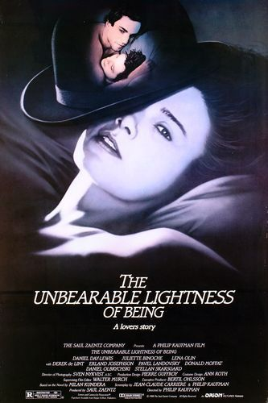
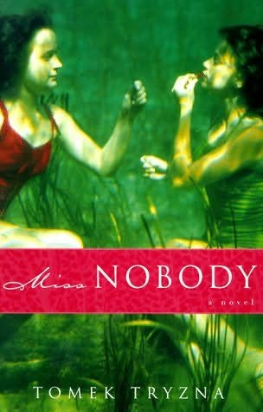

SLAV 516: FILM ADAPTATIONS OF POLISH AND CZECH LITERARY WORKS

Freedom and love
Are dear to me;
My life I give,
Sweet love for thee,
Yet love I give
For liberty.

Alexander Petőfi
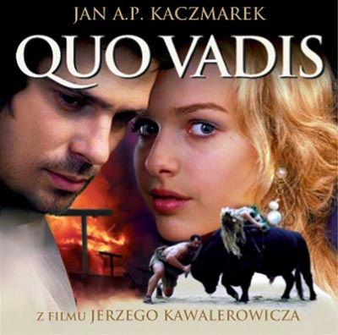
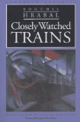

GENERAL INFORMATION
Class meetings: MW, 11:00-12:15 Instructor: Svetlana Vassileva-Karagyozova
Room: Wescoe 1046 Office: Wescoe 3054
Office hours: MW, 9:00-9:50
Office phone: (785) 864-2351
E-mail: svk@ku.edu

COURSE DESCRIPTION
This course examines classic Polish and Czech literary works from Positivism to Postmodernism and their film adaptations with a special focus on the philosophical and aesthetic interpretations of the themes of love, resistance and freedom in the West Slavic historical and cultural context. The course acquaints students with current theories in the field of film adaptation and provides an opportunity for analytical reflection on some of the most significant accomplishments of the 20th century Polish and Czech cinematography. The format of the course combines lecture, discussion, and small group activities.

REQUIRED TEXTS:

- Henryk Sienkiewicz. Quo Vadis New York: Macmillan, W.S. Kuniczak, trans., 1993. Available on-line at www.googlescholar.com
- Wladyslaw Reymont. The Peasants. London: Jarrolds, 1938.
- Jaroslaw Iwaszkiewicz. “The Wilko Girls”, In The Birch Grove and Other Stories. Budapest, New York: Central European University Press, 2002
- Jerzy Andrzejewski. Ashes and Diamonds. Evanston, IL: Northwestern University Press, 1991.
- Bohumil Hrabal. Closely Watched Trains. Evanston, IL: Northwestern University Press, 1995.
- Milan Kundera. The Unbearable Lightness of Being. New York: Harper & Row, 1987.
- Vladimir Paral. Lovers and Murderers. North Haven, CT: Catbird Press, 2001.
- Tomek Tryzna. Miss Nobody. New York: Doubleday, 1999.

REQUIRED FILMS:

- Quo Vadis (2001) by Jerzy Kawalerowicz, 165 min.
- The Peasants by Jan Rybkowski, 184 min.; VHS available in EGARC
- Promised Land (1975) Andrzej Wajda, 138 min.; DVD available in EGARC
- Young Girls of Wilko (1979) by Andrzej Wajda, 118 min.; VHS available in EGARC
- Ashes and Diamonds (1958) Andrzej Wajda, 103 min.; VHS available in EGARC
- Closely Watched Trains (1996) by Jiri Menzel, 93 min. DVD available in EGARC
- The Unbearable Lightness of Being (1988) by Philip Kaufman, 172 min. DVD available in EGARC
- Lovers and Murderers (2004) by Viktor Polesny, 108 min.
- Miss Nobody (1996) by Andrezj Wajda, 98 min.

SUGGESTED SECONDARY READINGS:

- Film Adaptation. James Naremore, ed. New Brunswick, New Jersey: Rutgers University Press, 2000. (chapter 1: Adaptation in Theory)
- Robert Stam, Alessandra Raengo. Literature and Film. A Guide to Theory and Practice of Film Adaptation. Malden, MA: Blackwell Publishers, 2005.
- Marek Haltof. Polish National Cinema. New York, Oxford: Berghahn Books, 2002.
- Aniko Imre. East European Cinemas. New York, London: Routledge, 2005.
- Dina Iordanova. Cinema of the Other Europe. London, New York: Wallflower, 2003.
- Peter Hames. The Czechoslovak New Wave. London, New York: Wallflower, 2005.
- The Cinema of Andrzej Wajda. The Art of Irony and Defiance. Elzbieta Ostrowska and John Orr, eds. London, New York : Wallfower, 2003.
Note: Additional instructional and reference materials will be provided in class by the instructor or posted on Blackboard.

NOVELS & FILMS FOR PRESENTATIONS:

- Milan Kundera. The Joke. New York: Harper & Row, 1982.
The Joke (1969) by Jaromir Jires, 80 min.; DVD available in EGARC
- Jaroslav Hasek. The Fateful Adventures of the Good Soldier Svejk. Book One. Chicago: Sadlon, 2000.
The Good Soldier Svejk (1956) 104 min.; DVD available in EGARC
- Bohumil Hrabal. I served the King of England. New directions classics, 2007
I served the King of England (2006) by Jiri Menzel, 120 min.
4) Jaroslaw Iwaszkiewicz. “The Birch Grove”, In The Birch Grove and Other Stories.
Budapest, New York: Central European University Press, 2002
The Birchwood (1972) by Andrzej Wajda, 100 min. Available in EGARC
- Witold Gombrowicz. “Pornografia”, In Cosmos and Pornografia. Grove Press, Inc. New York, 1985.
Pornografia (2003) by Jan Jakub Kolski, 117 min.; DVD available in EGARC
- Krzysztof Kieslowski. Duże zwierzę. Krakow: Znak, 2000.
Duze zwierze (2000) by Jerzy Sztur, 72 min.

CLASS ATTENDANCE AND PARTICIPATION IN CLASS DISCUSSIONS
Students are expected to attend all classes and be on time. More than three unexcused absences will lower your course grade by one letter (e.g. from an A to a B). More than five unexcused absences will result in failing the course regardless of your prior work or grades. If you need to miss a class for medical reasons, religious holidays or an emergency please notify me in advance (preferably by e-mail) and provide an official documentation next time you come to class. These absences may be excused and therefore not affect your grade. Absent students are responsible for acquiring the lecture notes and instructional materials distributed in the missed classes. Students are expected to be in class for the tests.
I have scheduled out-of-class screenings of the required films (time and place TBA) prior to their in-class discussions. Your attendance is mandatory only for the films unavailable in EGARC. Last, but not least, this is a student-centered course with an emphasis on discussion. All students benefit when everyone comes to class prepared and participates actively in class activities. Your regular attendance, preparation and active participation will be evaluated as part of your course grade.

READING/VIEWING JOURNAL
This is a reading-heavy course. You are required to keep a reading/viewing journal and submit the current entry at the end of every class session. I will provide you with a standard template containing some basic and more elaborate questions about the reading/film. You may take notes while you are reading/viewing but my advice is to complete the journal rubrics after you finish the novel/film. The purpose of this assignment is three-fold: 1) to help you summarize the gist of the text, 2) to draw your attention to some important aspects of the text that will be discussed in class, 3) to prepare you for the tests.

ORAL PRESENTATION
For this assignment each student will be asked to choose a novel and its cinematic adaptation from the recommended list in the syllabus and prepare a 15-minute oral presentation. Your presentation should include: a short bio of the writer/film director (if they haven’t been already discussed in class), a synopsis of the novel/film, and a brief discussion of the historical context, and some of the main issues the novel/film raises. You are encouraged to use PowerPoint and prepare hand-outs outlining the main points of your presentation. The presentations are scheduled for the last two class periods. Feel free to consult with me at any stage of your preparation for this assignment.

TESTS
There will be two tests in this course: one before Spring break and one at the end of the semester. They will consist of multiple-choice, identification and short open-ended questions. In addition, there will be three essay questions on selected topics from the in class discussions.

ANALYTICAL PAPERS
This assignment involves an in-dept analysis of a literary work and its film adaptation of your choosing (from the required list). For your first paper choose a novel/film from the ones scheduled in the first half of the semester. Your second paper should address a literary/cinematic work discussed after Spring break. Each paper should be 5-7 double spaced pages long. Graduate students are expected to use secondary sources and provide bibliography. In your analysis of the literary and cinematic texts follow the three steps below:
1) Place the novel/film within its historical and cultural context.
2) Explain how the novel and the film address the themes of love, resistance, and freedom and support your arguments with evidence from the texts.
3) Discuss the differences in the plot and the artistic devices employed by the writer and the film director.

GRADING
The grade for this course will be based on the following criteria:

- Class attendance and participation in class discussions – 20%

- Reading/Viewing journal – 10%

- Oral Presentation – 10%

- 2 Tests – 30% (15% each)

- 2 Analytical Papers – 30% (15 % each)

-----------------------------------------------------------
Total 100%

A 100-93 | B+ 89-88 | C+ 79-78 | D+ 69-68
A- 92-90 | B 87-84 | C 77-74 | D 67-64
 | B- 83-80 | C- 73-70 | D- 63-60
 |  |  | F below 59

OFFICE HOURS
Feel free to take advantage of the office hours. It is a good time to ask questions about course work, to receive feedback on your tests or papers, to seek advice on how to prepare your presentation, etc.

TENTATIVE CLASS SCHEDULE
Note: Course schedule and procedures are subject to change in the event of extenuating circumstances.

Date | Class | Homework
01/19 M | No class: Martin Luther King Holiday
01/21 W | Introduction: Film Adaptation theories
01/26 M | Brief overview of the history of Polish cinema
01/28 W | Brief overview of the history of Czech cinema | Read Quo Vadis
02/02 M | Henryk Sienkiewicz, Quo Vadis (novel)
02/04 W | Henryk Sienkiewicz, Quo Vadis (novel) | Film screening: Quo Vadis
02/09 M | Quo Vadis (film) | Read The Peasants
02/11 W | W. Reymont, The Peasants
02/16 M |  | Film screening: The Peasants
02/18 W | The Peasants (film) | Film screening: The Promised Land
02/23 M | The Promised Land (film)
02/25 W |  | Read The Wilko Girls
03/02 M | J. Iwaszkiewicz The Wilko Girls | Film screening: Young Girls of Wilko
03/04 W | Young Girls of Wilko (film)
03/09 M | Review; Paper # 1 due
03/11 W | Test # 1
03/16-03/22 | No classes: Spring Break | Read Closely Watched Trains
03/23 M | B. Hrabal Closely watched Trains | Film screening: Closely Watched Trains
03/25 W | Closely Watched Trains (film) | Read Ashes and Diamonds
03/30 M | J. Andrzejewski, Ashes and Diamonds | Film screening: Ashes and diamonds
04/01 W | Ashes and diamonds (film) | Read The Unbearable Lightness of Being
04/06 M | M. Kundera, The Unbearable Lightness of Being | Film screening: The Unbearable Lightness of Being
04/08 W | The Unbearable Lightness of Being (film) | Read Lovers and Murderers
04/13 M | Vl. Paral Lovers and Murderers | Film screening: Lovers and Murderers
04/15 W | Lovers and Murderers (film) | Read Miss Nobody
04/20 M | Tomek Tryzna, Miss Nobody | Film screening: Miss Nobody
04/22 W | Miss Nobody (film)
04/27 M | Review, Paper # 2 due
04/29 W | Test # 2
05/04 M | Presentations
05/06 W | Presentations

