School of Slavonic and East European Studies

University College London

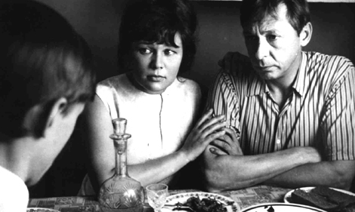

Russian Cinema: History, Politics, Society 2008-2009

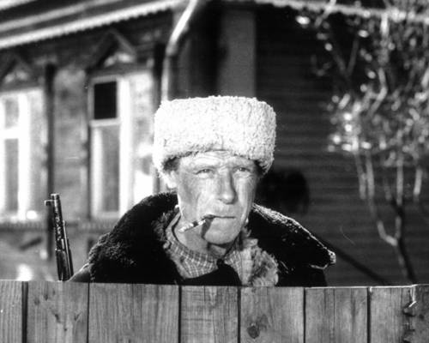

Course booklet: Spring Term 2009

SSEES RS1013, BA COURSE IN

RUSSIAN CINEMA: HISTORY, POLITICS, SOCIETY

2008-2009 [0.5 CU]

Course booklet, Term 2:

Table of contents:

Course description p. 2

Course aims and objectives p. 3

Teaching and Learning Methods. Course assessment p. 4

Introductory information: p. 5-6

Course plan p. 7

Russian and Soviet cinema from the end of the Thaw to the present day –
General bibliography and filmography pp. 8-10

The films pp. 11-31

Chronology of Russian cinema and society from the Thaw to the present day pp. 32-75

Course tutor: Julian Graffy
SSEES, UCL

RUSSIAN CINEMA: HISTORY, POLITICS, SOCIETY

Course description:

Course Title: Russian Cinema: History, Politics, Society.
Course Code: SSEES RS1013
Course-unit value 0.5 cu

Availability: First and Second Terms, 2008-2009
Open to: Year 1 students of degrees with Russian;
SSEES/UCL interdepartmental students in Years 1-2; Affiliate students.

Course leader: Julian Graffy, with Ms Candyce Veal

Russian and Soviet cinema has borne important witness to the turbulent and traumatic events of the twentieth century. More than other national cinemas, film in Russia has reflected some of the most important ideological, political, and social shifts. But it is also important to note that this is a course in Russian film, examining the way in which it represents and responds to historical, political and social change, rather than a course in history, politics or society. It is the first of a programme of four courses in Russian film available to students at SSEES.

This course offers a selection of films which illustrate the importance of cinema as an indicator of change. Chronologically, it ranges from the pre-revolutionary period to the post-Soviet years. The works included have been chosen especially for the way in which they illustrate some of the major changes which have taken place this century: social developments in the late Tsarist period, the October Revolution, the Stalinist thirties, the Khrushchev thaw, the Brezhnevite stagnation, perestroika and glasnost´, the collapse of the Soviet Union, and the immense social changes of recent years. Many of them are landmarks of Russian cinema, popular with viewers and film critics alike.

The course is divided into four parts, each lasting five weeks. Four films are studied in each part, preceded by a contextualizing lecture.

Russian is not a prerequisite for this course because all the works chosen are available in subtitled versions.

RUSSIAN CINEMA: HISTORY, POLITICS, SOCIETY

Course aims and objectives:

Aims:

1. To examine the ways in which Russian cinema has approached the analysis of major historical, political and social change in Russia in the twentieth century.

2. To analyse in detail 16 Russian films on these subjects spanning the century.

Objectives: By the end of the course, you will have acquired:

1. Experience in the study of film.

2 A good basic knowledge of the ways social and historical issues have been addressed by Russian cinema.

3. An in-depth knowledge of the individual films which you research and on which you write your essays.

4. The ability to make presentations about individual films and to articulate your ideas in class discussion.

RUSSIAN CINEMA: HISTORY, POLITICS, SOCIETY

Teaching & Learning Methods: Number of Hours:

Lectures 4
Seminars 16
Viewings of films 32 [16 x 2]
Private Study 40
Required Written Work 10
Revision 20

Attendance:

Attendance at classes is compulsory and will be monitored. You are required to attend BOTH the film showing and the discussion in order to be marked as present unless you have explicit permission from the course tutor to watch the film on your own. Failure to attend enough sessions will result in your being banned from sitting the examination. If you have a valid reason for absence, such as illness, you must inform the course teacher.

Assessment:

Assessment will be by means of coursework and examination.

Coursework:

ONE essay each term, on individual films watched during the course, to be presented with bibliography and footnotes. The essays, which must be chosen from those listed in the course booklet, are to be submitted by the end of the first and second terms respectively. Students will also be required to make presentations.

The coursework essays are a necessary condition of being allowed to proceed to the written examination, but they do not themselves count towards the final mark for the course.

Examination:

A two-hour written examination, in which two questions must be answered. Both questions carry equal weight. The examination will normally be taken in May.
The examination rubric for the course reads as follows:
Answer TWO questions, ONE from Section A and ONE from Section B.
You may NOT write on the same text in detail in more than one examination (this includes all forms of examination, including extended essays and free-standing dissertations and applies to all years of the degree course).
Candidates are required to answer ALL questions in English.
RUSSIAN CINEMA: HISTORY, POLITICS, SOCIETY

Introductory Information

This term’s course covers Russian and Soviet cinema’s treatment of the themes of history, politics and society from the Thaw to the present day. It lasts for 10 weeks [Weeks 1-5 and 7-11 of term. Week 6 is a Reading Week.]

It consists of:

a) An introduced weekly showing of a film (two hours):

These sessions will take place on: Fridays at 9.00 in Taviton 432

b) A weekly discussion of the film seen (one hour):

These sessions will take place on: Fridays at 12.00 in Taviton 345 OR at 2.00 in Taviton 345

Students will be asked by turn to take a lead in the discussion.

The SSEES videotape and DVD collection:

SSEES has a very large collection of Russian, Soviet, CIS, Central and East European feature and documentary films, and Western feature and documentary material on the countries of our region. The collection can be viewed in the Audiovisual Room in SSEES library.

A full catalogue of the collection is on the SSEES Website at http://www.ssees.ac.uk/videos/intro.htm
and there is a dedicated computer in the Library entrance hall.

This will lead you to the following links:

* Recent Additions
* Material held on DVD

FULL LISTINGS:

* Feature Films
* Animation
* Documentaries on History, Politics and Current Events
* Documentaries on Literature, Cinema and other Arts
* Language Learning Materials

* Internet Resources on Russian Cinema

* Russian Cinema Research Group

With specific relevance to this course, in the Feature Films section you will find indexes of
Russia, Soviet and CIS feature films, listed chronologically
Russia, Soviet and CIS feature films, listed by director

In the Documentaries on Literature, Cinema and other Arts section you will find an index entitled Documentary Materials about Russian, CIS, Central and East European Cinema which contains a number of documentaries about Russian cinema, its directors and actors.

Watching videotapes and DVDs:

You can use the Audiovisual Room collection to re-watch films you have seen on the course or to watch other Russian feature films and documentary material to provide context. To watch a particular film consult the catalogue and establish the Call Number; then ask for this number at the Library issue desk. You may not borrow the videos or DVDs.

Background reading:

Most, but NOT ALL the books on Russian and Soviet cinema are held in the
R XX 4 c section of SSEES library. If you cannot find a book in this section, check in the library catalogue. Some books on cinema are kept in other sections or in store.
Most books on cinema are on the computer catalogue, but some are still on the card catalogue. The library also subscribes to the most important current Russian film periodicals. There are also some books on Russian cinema and on cinema theory and history both in the main University College Library in the Wilkins Building and in the University of London Library in the Senate House building in Malet Street. These libraries subscribe to several general film periodicals not stocked in SSEES. All SSEES students have automatic access to University College Library and have the right to join the University of London Library and are encouraged to do so. If you have any problems finding materials, ask me.

Internet resources on Russian cinema:

There are a continually increasing number of websites on Russian cinema, of varying degrees of usefulness. In general Internet information is best on recent films.
The SSEES Web Site has direct links to some particularly useful sites. Go to the SSEES Film and Video Database in the way indicated above and click on Internet Resources on Russian Cinema.
If you have any questions, do not hesitate to ask me, or to email me at
j.graffy@ssees.ucl.ac.uk
SSEES, UCL: RUSSIAN CINEMA: HISTORY, POLITICS, SOCIETY

Course plan, Term 2:

Film viewings: 2 hours per week, on Fridays at 9.00 in Taviton 432
Seminars: 1 hour per week, on Fridays at 12.00 in Taviton 345 OR at 2.00 in Taviton 345

Teacher: Julian Graffy, assisted by Ms Candyce Veal

Course outline:

Week 1: Russian Cinema and Society from the Thaw to the 1980s (Lecture)

Weeks 2 and 3: The Thaw and young people – the cinematic view then and now

Week 2: Georgii Daneliia - Ia shagaiu po Moskve (I Walk Around Moscow) 1963

Week 3: Pavel Chukhrai - Voditel´ dlia Very (A Driver for Vera) 2004

Weeks 4 and 5: Brezhnev period Cinema – Russians and non-Russians

Week 4: Vitalii Mel´nikov – Mama vyshla zamuzh (Mum Got Married) 1969

Week 5: Irakli Kvirikadze – Mocurave (Plovets, The Swimmer) 1981

Week 6: READING WEEK

Week 7: Late and Post-Soviet cinema (Lecture)

Weeks 8 – 11: Post Soviet cinema – winners and losers

Weeks 8 – 9: Losers?

Week 8: Dmitrii Astrakhan – Vse budet khorosho (Everything Will Be OK) 1995

Week 9: Petr Lutsik – Okraina (Outskirts) 1998

Weeks 10 – 11: Winners?

Week 10: Aleksei Balabanov – Brat (Brother) 1997

Week 11: Filipp Iankovskii - V dvizhenii (In Motion) 2002
Russian and Soviet cinema from the end of the Thaw to the present day - general bibliography and filmography:

Most, but NOT ALL the books on Russian and Soviet cinema are held in the R XX 4 c section of the library. If you cannot find a book in this section, check in the library catalogue. Some books on cinema are kept in other sections or in store.
Most books on cinema are on the computer catalogue, but some are still on the card catalogue.

For general information about books on Russian cinema see the Course Booklet for last term.

General reading and filmography for the modern period:

SOVIET CINEMA OF THE KHRUSHCHEV PERIOD, 1953-1964:

Attwood. L. ‘Khrushchev and the “Thaw”’, pp. 71-77 of her ‘Women, cinema and society’ in Red Women on the Silver Screen. Soviet Women and cinema from the beginning to the end of the Communist era, ed. L. Attwood, London, 1993

Condee, N. ‘Cultural codes of the Thaw’, in Nikita Khrushchev, ed. W. Taubman, S. Khrushchev and A. Gleason, New Haven and London, 2000, pp. 160-76 (on the cultural context)

Margolit, E. ‘Peizazh s geroem’, in Kinematograf ottepeli. Kniga pervaia, resp. ed. V. Troianovskii, Moscow, 1996, pp. 99-117; translated as ‘Landscape, with hero’ in Springtime for Soviet Cinema. Re/viewing the 1960s, ed. A. Prokhorov, Pittsburgh, 2001, pp. 29-49

Martin, M. ‘Le dégel’, in his Le cinéma soviétique de Khrouchtchev à Gorbatchev (1955-1992), Lausanne, 1993, pp. 19-66

Woll, J. Real Images. Soviet Cinema and the Thaw, London and New York, 2000

Zorkaya, N. The Illustrated History of Soviet Cinema, New York, 1989, chapters 5 and 6, pp. 195-266

=============================================================
SOVIET CINEMA OF THE BREZHNEV PERIOD, 1964-1982

Attwood. L. ‘Leonid Brezhnev: the “Era of Stagnation”’, in her ‘Women, cinema and society’ in Red Women on the Silver Screen. Soviet Women and cinema from the beginning to the end of the Communist era, ed. L. Attwood, London, 1993, pp. 78-94

Faraday, G. Revolt of the Filmmakers. The Struggle for Artistic Autonomy and the Fall of the Soviet Film Industry, University Park, Pennsylvania, 2000 [see especially chapter 3, ‘The cinematic field under Brezhnev’, pp. 87-119]

Golovskoy, V. S., with J. Rimberg. Behind the Soviet Screen. The Motion-Picture Industry in the USSR 1977-1982, Ann Arbor, 1986

Lawton, A. Kinoglasnost: Soviet cinema in our time, Cambridge, 1992, chapter 1, pp. 7-51

Martin, M. ‘La stagnation’, in his Le cinéma soviétique de Khrouchtchev à Gorbatchev (1955-1992), Lausanne, 1993, pp. 67-132

Shlapentokh, D. and Shlapentokh, V. Soviet Cinematography 1918-1991. Ideological Conflict and Social Reality, New York, 1993, pp. 147-72

Zorkaya, N. The Illustrated History of Soviet Cinema, New York, 1989, chapters 6 and 7, pp. 225-302

=============================================================
THE LAST YEARS OF SOVIET CINEMA, 1982-1991

Attwood, L. ‘1982-1985: The interim period’, ‘Perestroika, glasnost´ and the cinema’, in her ‘Women, cinema and society’ in Red Women on the Silver Screen. Soviet Women and cinema from the beginning to the end of the Communist era, ed. L. Attwood, London, 1993, pp. 95-98, 99-123

Cahiers du Cinéma. Spécial URSS. Ciné-perestroika: le rideau déchiré, Supplément au no. 427, Paris, 1990

Christie, I ‘The Cinema’, Culture and the Media in the USSR Today, ed. J. Graffy and G.A. Hosking, London, 1989, pp. 43-77

Faraday, G. Revolt of the Filmmakers. The Struggle for Artistic Autonomy and the Fall of the Soviet Film Industry, University Park, Pennsylvania, 2000 [see especially chapter 4, ‘Liberation and decay’, pp. 121-58]

Galichenko, N. Glasnost - Soviet Cinema Responds, Texas Film Studies, University of Texas Press, Austin, 1991. [includes filmographies of 33 directors]

Horton, A. and Brashinsky, M. The Zero Hour. Glasnost and Soviet Cinema in Transition, Princeton, New Jersey, 1992

Lawton, A. Kinoglasnost: Soviet cinema in our time, Cambridge, 1992

Lenfilm and the Liberation of Soviet Cinema, ed. M. Müller and H. van der Meulen, Rotterdam, 1990

Martin, M. ‘La perestroïka’, in his Le cinéma soviétique de Khrouchtchev à Gorbatchev (1955-1992), Lausanne, 1993, pp. 133-81

Russian Critics on the Cinema of Glasnost, ed. M. Brashinsky and A. Horton, Cambridge, 1994

Shlapentokh, D. and Shlapentokh, V. Soviet Cinematography 1918-1991. Ideological Conflict and Social Reality, New York, 1993, pp. 173-244

Filmography:

The Arts and Glasnost: 1. Cinema, directed by Daisy Godwin, Omnibus, BBC1, 1987, 60 minutes Call number V-625

Kinoperestroika, directed by Peter Adam, Arena, BBC2, 18 May 1990, 60 minutes Call number V-589 and Call number V-686

=============================================================
POST-SOVIET CINEMA, 1991-2008

Beumers, B. ‘Cinemarket, or the Russian Film Industry in "Mission Possible"‘, Europe-Asia Studies, 51, 1999, pp. 871-96 [Very detailed information on the running of the industry in the 1990s and a number of useful tables.]

Faraday, G. Revolt of the Filmmakers. The Struggle for Artistic Autonomy and the Fall of the Soviet Film Industry, University Park, Pennsylvania, 2000 [see especially chapter 5, ‘From Masochism to Mythology’, pp.159-93]

Lawton, Anna Imaging Russia 2000: Film and Facts, Washington, DC: New Academia, 2004, ix + 348 pp.

Russia on Reels: The Russian Idea in Post-Soviet Cinema, ed. Birgit Beumers, I.B. Tauris, London and New York, 1999

WEEK 2

GEORGII DANELIIA

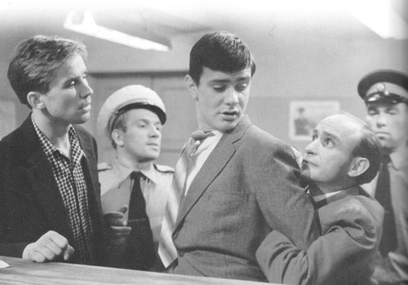
Я шагаю по Москве [Ia shagaiu po Moskve] [I Walk around Moscow]

Mosfil´m, 1963; released 11 April 1964
Screenplay Gennadii Shpalikov
Photography Vadim Iusov
Music Andrei Petrov

Kolia Nikita Mikhalkov
Volodia Aleksei Loktev
Alena Galina Pol´skikh
Sasha Evgenii Steblov
Cleaner Vladimir Basov
with Arina Aleinikova , Valentina Anan´ina, Rolan Bykov, Inna Churikova, Irina Miroshnichenko, Mariia Vinogradova, Oleg Vidov, Boris Bitiukov, Aleksei Smirnov, Lev Durov, Irina Skobtseva, Liubov´ Sokolova, Danuta Stoliarskaia, Gennadii Ialovich
73 minutes

Dubbed into English: Call number V-79

In Russian: Call number DVD-110
Region code
Aspect ratio
Languages No subtitles
Features Restored sound. Information on the film (text).
Source Mosfil´m digital

In Russian: Call number DVD-354
Region code All
Aspect ratio Widescreen 16:9
Languages No subtitles
Features Fully restored sound and picture
Biographies and filmographies for the director, Georgii Daneliia, the scripwtwrier, Gennadii Shpalikov, the director of photography, Vadim Iusov, and the actors Nikita Mikhalkov, Aleksei Loktev, Galina Pol´skikh and Evgenii Steblov
‘Arkhiv’ is pictures from the shooting of the film.
‘Rasskaz G. Daneliia o s´´emkakh fil´ma’, 35½ minutes, in Russian without subtitles
Source Krupnyi plan

The song:

"Я шагаю по Москве"
Music Andrei Petrov
Words Gennadii Shpalikov
Бывает всё на свете хорошо
В чём дело сразу не поймёшь
А просто летний дождь прошёл
Нормальный летний дождь
Мелькнёт в толпе знакомое лицо
Весёлые глаза
А в них блестит Садовое кольцо
А в них бежит Садовое кольцо
И летняя гроза
А я иду шагаю по Москве,
И я ещё пройти смогу,
Солёный Тихий океан
И тундру, и тайгу.
Над лодкой белый парус распущу
Пока не знаю с кем
А если я по дому загрущу
Под снегом я фиалку отыщу
И вспомню о Москве
И вспомню о Москве...

Suggested reading:

Woll, J. Real Images. Soviet Cinema and the Thaw, London and New York, 2000 [esp. pp. 158-60]

Essay questions:

Josephine Woll has described Georgii Daneliia’s film Ia shagaiu po Moskve (I Walk Around Moscow) as ‘attractive […], enjoyable […] amusing’ but ‘anodyne.’ Consider Daneliia’s representation of contemporary Soviet youth in the light of Woll’s assessment. (Russian Cinema – History, Politics, Society, 2007)

Georgii Daneliia said of his film Ia shagaiu po Moskve (I Walk Around Moscow) that ‘It is not a slice of life, nor a newsreel. It is a modern fairy tale with noble heroes and beautiful fairies.’ Discuss. (Russian Cinema – History, Politics Society, 2008)

WEEK 3

PAVEL CHUKHRAI

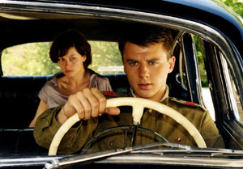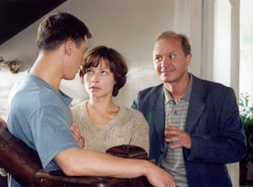
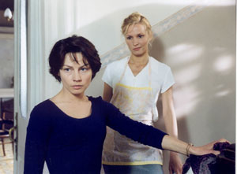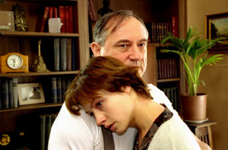

Водитель для Веры [Voditel´ dlia Very] [A Driver for Vera]

Pervyi kanal, Prodiuserskaia firma Igoria Tolstunova, Telekanal 1+1 (Ukraine), with the support of the Sluzhba kinematografii Ministerstva kul´tury Rossiiskoi Federatsii, 2004
General producer Igor´ Tolstunov, Aleksandr Rodnianskii
Producer Mikhail Zil´berman
Screenplay Pavel Chukhrai
Photography Igor´ Klebanov
Production Design Ol´ga Kravchenia
Music Eduard Artem´ev
Viktor Igor´ Petrenko
Vera Alena Babenko
General Serov Bogdan Stupka
Adjutant Savel´ev Andrei Panin
The maid, Lida Ekaterina Iudina
Zinaida Marina Golub
General Klimenko Valerii Barinov
Anzhela Natal´ia Gudkova
Redhead Alisa Grebenshchikova
Rojes Dmitrii Vysotskii
Nanny Natal´ia Gorshkova
First investigator Aleksei Zelenskii
Doctor at regional hospital Aleksandr Mezentsev
Gynaecologist Vladimir Koval´
Second investigator Sergei Udovik
Pathologist Aleksandr Shavrin
Adjutant Oleg Lopukhov
Head of disinfectors Aleksandr Fastovskii
111 minutes
In Russian with optional Russian and English subtitles

Call number DVD 447

Region code 5
Aspect ratio 16:9
Languages Optional Russian and English subtitles
Features Film about the film with commentary by the filmmakers, 16 minutes, in Russian without subtitles
Biographies and filmographies for the actors Igor´ Petrenko, Alena Babenko, Bogdan Stupka, Andrei Panin and Ekaterina Iudina, the director and scriptwriter, Pavel Chukhrai, the producers Igor´ Tolstunov and Aleksandr Rodnianskii, the director of photography, Igor´ Klebanov and the production designer Ol´ga Kravchenia
The filmmakers about the film (text, in Russian, the views of Pavel Chukhrai, Bogdan Stupka, Igor´ Petrenko, Alena Babenko, Ol´ga Kravchenia and Igor´ Klebanov)
‘Kak snimalsia “Voditel´ dlia Very”’ (text, in Russian)
Source Pervaia videokompaniia

Suggested reading:

Screenplay:

Chukhrai, P. ‘Voditel´ dlia Very’, Iskusstvo kino, 2002, 6, pp. 141-72 [in Russian]

On the film, see:

McCausland, G. ‘Pavel Chukhrai, Voditel´ dlia Very’, in Kinokultura, http://www.kinokultura.com/reviews/R1-05voditelvery.html [in English]

Some responses by Russian critics will be supplied in translation after the class

Essay questions:

Consider the ways in which the atmosphere of the Khrushchev years is evoked in Pavel Chukhrai’s film Voditel´ dlia Very (A Driver for Vera). (Russian Cinema – History, Politics, Society, 2007)

In the interviews he gave after the premiere of Voditel´ dlia Very (A Driver for Vera), the director Pavel Chukhrai denied that his film was a political work and insisted that it was, first and foremost, a love story. Consider the relationship between the political and the personal in this film in the light of the director’s remark. (Russian Cinema – History, Politics Society, 2008)

WEEK 4

VITALII MEL´NIKOV

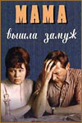
Мама вышла замуж [Mama vyshla zamuzh] [Mum Got Married]
Lenfil´m, Pervoe tvorcheskoe ob´´edinenie, 1969; released 25 March 1970
Screenplay Iurii Klepikov
Photography Dmitrii Dolinin
Music Oleg Karavaichuk
Boris Nikolai Burliaev
Zina, his mother Lius´ena Ovchinnikova
Viktor Oleg Efremov
Boris’s aunt Katia Liudmila Arinina
Vera Larisa Burkova
Leonid Viktor Il´ichev
With: Konstantin Tiagunov, Arkadii Trusov
80 minutes

In Russian: Call number V-1221

In Russian with English subtitles: Call number DVD-107
Region code 1, 2 and 5
Aspect ratio 4: 3
Languages Optional Russian, English and German subtitles
Features Interview with Nikolai Burliaev, in Russian without subtitles, 9 minutes.
Biographies and filmographies of the director, Vitalii Mel´nikov, and the actors Nikolai Burliaev, Lius´ena Ovchinnikova and Oleg Efremov
Source SR Digital

Suggested reading:

Kudriavtsev, S. Svoe kino, Moscow, Dubl´-D, 1998, pp. 100-01

Mel´nikov, V. Zhizn´, kino, St Petersburg, KinoMel´nitsa, 2005, pp. 212-25

Essay questions:

Consider the picture of family life in the Soviet Union of the Brezhnevite era that emerges from Vitalii Mel´nikov’s film Mama vyshla zamuzh (Mum Got Married). (Russian Cinema – History, Politics, Society, 2007)

It has been suggested that the director Vitalii Mel´nikov is more interested in creating precise psychological portraits of his protagonists than in effecting any kind of social analysis. How appropriate is this description of Mel´nikov’s method in relation to his film Mama vyshla zamuzh (Mum Got Married)? (Russian Cinema – History, Politics Society, 2008)

WEEK 5

IRAKLI KVIRIKADZE

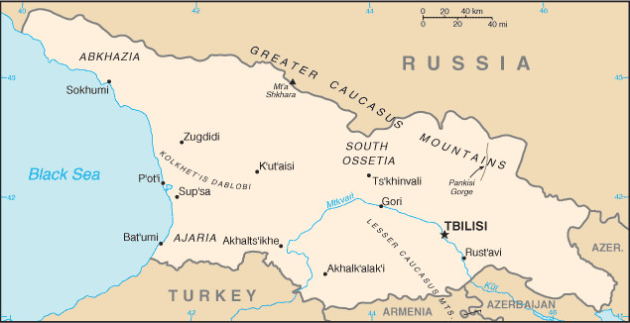

Mocurave [Пловец] [Plovets] [The Swimmer]
Gruziia fil´m, Pervoe tvorcheskoe ob´´edinenie, 1981; release permitted of censored version 22 September 1981; director’s version restored 1987

Screenplay Irakli Kvirikadze
Photography Guram Tugushi
Music Teimuraz Bakuradze, and extracts from Bizet’s The Pearl Fishers
Sound Madonna Tevzadze
Design Aleksandr Dzhanshiev
Costumes Tamila Mamaladze

Cast:

1913
Durmishkhan Dumbadze Elgudzha Burduli
Thomas Winston, an English swimming champion and businessman Teimuraz Murvanidze
Francesca Coty, his wife, a silent film star Maka Makharadze

1947
Domenti Dumbadze, Durmiskhan’s son Ruslan Mikaberidze
Lala, his sister Nana Kvachantiradze
Odisei Meskhi, 1941 swimming marathon champion Guram Pirtskhalava
Beso Antadze, an artist in love with Lala Gia Lezhava
Isidor Buadze, chairman of the sport committee Imedo Kakhiani

1980
Anton Dumbadze, Durmiskhan’s grandson Baadur Tsuladze
The director Irakli Kvirikadze
His assistant Nana Djordjadze

80 minutes
In Georgian and Russian with English subtitles: Call number V- 209
In Georgian and Russian: Call number V- 210; on this copy the film is preceded by 5 mins on K. in the series Liniia kino

A swimming herdsman in 1913, his son, who leads a mass swim in 1947, and the grandson, making a film in 1980, are the three generations of a Georgian family in this allegory of life under three political regimes. The film ran into trouble with the authorities and was shelved. A cut version was shown at the Rotterdam Film Festival in 1983, but the integral version was not released until 1987, when it won the Grand Prix at the San Remo Film Festival.

Suggested reading:

Galichenko, N. Glasnost. Soviet Cinema Responds, Austin, Texas, 1991, pp. 81-85

Graffy, J. ‘History, Memory, Water: the Reclamation of Georgian Identity in Irakli Kvirikadze’s Film The Swimmer’, Studies in Russian and Soviet Cinema, 1, 2007, 3, pp. 299-327 (also available electronically via UCL Library electronic journals using your UCL password)

Cultural background:

Ascherson, N. Black Sea, London, 1995

King, Charles, The Black Sea. A History, Oxford University Press, 2004

Sprawson, C. Haunts of the Black Masseur. The Swimmer as Hero, London, 1992

Essay questions:

Discuss the relationship between continuity and rupture in both the personal and the national spheres in Irakli Kvirikadze’s film Mocurave (Plovets, The Swimmer). (Russian Cinema – History, Politics, Society, 2007)

The director Irakli Kvirikadze has suggested in relation to his film Mocurave (Plovets, The Swimmer) that: ‘Legend, myth, is the main truth.’ What is the role of myth/legend in this film, in your view, and to what extent does it contribute to its ‘truthfulness’? (Russian Cinema – History, Politics Society, 2008)
WEEK 8

DMITRII ASTRAKHAN

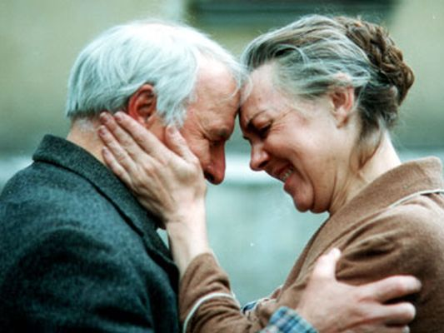
Все будет хорошо [Vse budet khorosho] [Everything Will Be All Right]

Nikola-fil´m, Fora-fil´m, Komitet Rossiiskoi federatsii po kinematografii, Lenfil´m, 1995
Producers Igor´ Kalenov, Andrei Razumovskii, Iurii Romanenko
Screenplay Oleg Danilov
Photography Iurii Vorontsov
Music Aleksandr Pantykin
Song lyrics Vadim Pugach
Prodcution Design Sergei Kokovkin

Kolia Orlov Anatolii Zhuravlev
Olia Tuzova Ol´ga Ponizova
Petia Smirnov Mark Goronok
Konstantin Smirnov, Petia’s father Aleksandr Zbruev
Semen Tuzov, Olia’s father Valentin Bukin
Auntie Katia, Kolia’s mother Irina Mazurkevich
“Granddad” Volodia Mikhail Ul´ianov
Pet´ka Samsonov Iura Visokoborskis
Natasha Samsonova Ol´ga Beliaeva
With: Vladimir Kabalin, Valerii Kravchenko, Nikolai Stoiakin, Evgeniia Igumnova, Antonina Vvedenskaia, Gennadii Svir´, Irina Trofimova, Anna Banshchikova, Andrei Fedorov, Aleksandr Glazun, Valentina Panina, Vladimir Leletko, A. Slastin, A. Baianov, Ts. Rem, Viktor Gogolev, V. Golovko

100 minutes

DVD: Call number DVD 494, in Russian with optional subtitles
Region code All
Aspect ratio Standard
Languages Optional Russian, English, French, Spanish and German subtitles
Features Biographies and filmographies for the director, Dmitrii Astrakhan, the producer, Igor´ Kalenov, and the actors Aleksandr Zbruev, Ol´ga Ponizova, Mikhail Ul´ianov and Anatolii Zhuravlev
Album of photographs
Source Russian

Suggested reading:

Graffy, J. ‘Dmitri Astrakhan: Popular Cinema for a Time of Uncertainty’ in Russia on Reels: The Russian Idea in Post-Soviet Cinema, ed. Birgit Beumers, I.B. Tauris, London and New York, 1999, pp. 161-78, 201-05

Some responses by Russian critics will be supplied in translation after the class

Essay questions:

Consider the ways in which the old myths of the Soviet Union and the new myths of post-Soviet Russia are combined by Dmitrii Astrakhan in his film Vse budet khorosho (Everything Will Be OK). (Russian Cinema – History, Politics, Society, 2007)

‘All I think about is telling an engaging story.’ (Dmitrii Astrakhan) To what extent, in your view, is Astrakhan’s film Vse budet khorosho (Everything Will Be OK) just ‘an engaging story’, and to what extent does it offer evidence of the social conditions and the mentality of post-Soviet Russia? (Russian Cinema – History, Politics Society, 2008)

WEEK 9

PETR LUTSIK

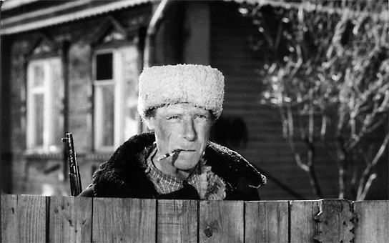
Окраина
Okraina
Outskirts
Kinokompaniia Utro XXI veka, Goskino Rossii 1998
Executive producer Lev Kagno
Producer Petr Lutsik
Screenplay Petr Lutsik and Aleksei Samoriadov
Photography Nikolai Ivasiv
Design Andrei Bessolitsyn
Editing director Svetlana Gural´skaia
Sound Viacheslav Kliuchnikov
With music by Georgii Sviridov from the films Voskresen´e, directed by Mikhail Shveitser, 1960-1961 and Voin Skanderbek and by Gavriil Popov from the film Chapaev, directed by the Vasil´ev “Brothers”, 1934
Chief consultant Leonid Rybakov

Filipp Il´ich Safronov Iurii Dubrovin
Kol´ka Poluianov Nikolai Olialin
Vasilii Ivanovich Perfil´ev Aleksei Vanin
Pan´ka Morozov Aleksei Pushkin
Evdokiia, Pan´ka’s mother Rimma Markova
Boss in office Viktor Stepanov
The Lykov brothers Anatolii Koshcheev and Viktor Venes
Makhotin Aleksandr Vdovin
Tamara, Makhotin’s wife Galina Zolotareva
Simavin, the Obkomovets Oleg Makshantsev
Simavin’s son Viacheslav Kulakov
95 minutes
In Russian

DVD 391:
Region code
Aspect ratio
Languages English subtitles
Features Interview with Petr Lutsik, 52 minutes, in Russian with English voiceover, a film in the series Perpendikuliarnoe kino, RTR-fil´m and Studiia K-2, 1999, written and directed by Irina Vasil´eva
Source Facets Video

DVD 382:
Region code 5
Aspect ratio 4:3
Languages No subtitles
Features Chapter selection
Source Khaus M

The text at the beginning of the film reads:
Nepravil´nyi u istorii khod.
Shlo vse nekhorosho. A vyshlo i vovse plokho. V 199 godu v step´ na khutor Romanovskii priekhali buril´shchiki i nachali burit´ zemliu. Buntovali khutorskie muzhiki, no usmirili ikh bystro.
Pokazali i bumagu o chetyrekh gosudarstvennykh pechatiakh. Poluchalos´ po toi bumage, chto vse 13.5 tysiach gektar stepi, byvshii kolkhoz “Rodina”, narezannye teper´ na fermerskie uchastki, vsia zemlia Romanovskaia prodana. A komu i kem, neizvestno.
Vot takaia vyshla nespravedlivost´ i prosto glupost´. A zria...

The course of history is unfair.
Everything was going badly. But it turned out extremely badly. In 199- drill-operators came into the steppe, on to the Romanov farmstead and began to drill the land. The farmstead peasants rebelled, but they were quickly pacified.
They also showed them a paper with four state stamps on it. According to that paper, all the 13,500 hectares of steppe that made up the former Rodina collective farm had now been cut up into private farmers’ plots, all the Romanov land had been sold. But who to and by whom was not known.
So what happened was unfair and simply stupid. And they shouldn’t have done it…

The text is also narrated. The voice says not ‘V 199 godu’ but ‘V proshlom godu’ (i.e. not ‘199-’ but ‘last year’.)

Poem extract:

Uzh pozdno. Putnik odinokii
Odelsia burkoiu shirokoi.
Za dubom nizkim i gustym
Doroga skrylas´. Veter duet.
Kon´ spotykaetsia pod nim,
Khrapit, kak budto gibel´ chuet
I vstal. Divitsia, slez sedok
I vidit propast´ pred soboi,
A tam na dne ee potok
Vo mrake beshenoi volnoi
Shumit. Vdrug vidit on v dali pustoi
Trepeshchet ogonek.
I snova saditsia na konia likhogo
I cherez silu skachet kon´
Tuda, gde svetitsia ogon´.

Essay questions:

‘Outskirts is a shifty and ironic parable that can be read in several ways’ (Dennis Harvey). Discuss.

Igor´ Mantsov describes Petr Lutsik’s Okraina (Outskirts) as a film in which a ‘simple anecdote’ acquires ‘real socio-cultural significance’, Consider the ways in which Lutsik achieves this effect. (Russian Cinema: History, Politics, Society, 2005)

WEEK 10

ALEKSEI BALABANOV

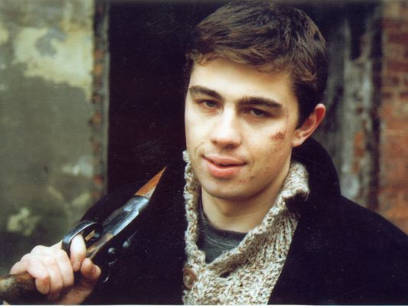
Брат [Brat] [Brother]
Kinokompaniia STV, Gosudarstvennyi komitet Rossiiskoi federatsii po kinematografii, 1997
Producer Sergei Sel´ianov
Screenplay Aleksei Balabanov
Photography Sergei Astakhov
Music Viacheslav Butusov
Songs Viacheslav Butusov and Il´ia Kormil´tsev
Sound Maksim Belovolov
Consultant Nikolai Zhitkov
Danila Bagrov Sergei Bodrov
Viktor, Bagrov’s brother Viktor Sukhorukov
Sveta Svetlana Pis´michenko
German Iurii Kuznetsov
Ket Mariia Zhukova
Butusov Viacheslav Butusov
Zinka Irina Rakhshina
Kruglyi Sergei Murzin
Nervous bandit Anatolii Zhuravlev
Policeman Igor´ Shibanov
Stepa Andrei Fedortsov
95 minutes

Call number DVD-1: In Russian with English subtitles
NB – The English subtitles on this version are appalling. They are much better on DVD-251, below
Region code All
Aspect ratio
Languages Optional Russian, English, Spanish, French, German, Italian, Dutch, Swedish and Czech subtitles.
Features Biographies of Aleksei Balabanov, Sergei Bodrov and Viacheslav Butusov; short film to Butusov’s song ‘Posle dozhdia’
Source STV; Amalgama

Call number DVD-251: In Russian with English subtitles
Region code 0
Aspect ratio Anamorphic 166:1
Languages Optional English subtitles
Features Theatrical Trailer
Filmographies for the director, Aleksei Balabanov, and the actors Sergei Bodrov and Viktor Sukhorukov.
David Parkinson film notes – text.
‘After Rain’ – Balabanov music video, 3 minutes.
Source Tartan

Suggested reading:

On the film:

Beumers, B. ‘To Moscow! To Moscow? The Russian hero and the loss of the centre’, Russia on Reels: The Russian Idea in Post-Soviet Cinema, ed. Birgit Beumers, I.B. Tauris, London and New York, 1999, pp. 76-87

Beumers, B. ‘Alexei Balabanov’s Brothers and Bodrov’s Sisters’, in her Pop culture Russia! : media, arts, and lifestyle, Santa Barbara, Calif., ABC-CLIO, 2005, pp. 93-96

Beumers, B. ‘Brat’ / ‘Brother’, in The Cinema of Russia and the Former Soviet Union, ed. B. Beumers, 24 Frames series, London and New York, Wallflower Press, 2007, pp. 233-41

Day, J. ‘Strange spaces: Balabanov and the Petersburg text’, Slavic and East European Journal, 49, 2005, pp. 612-24

Graffy, J. ‘Brother’, Sight and Sound, vol. 10, no. 5, May 2000, p. 44

Hashamova, Yana Pride and Panic. Russian Imagination of the West in Post-Soviet Film, Bristol and Chicago, Intellect, 2007, pp. 39-62

Larsen, S. ‘National identity, cultural authority and the Post-Soviet blockbuster: Nikita Mikhalkov and Aleksei Balabanov’, Slavic Review, 62, 2003, pp. 494-511 [pp. 504-09]

Some responses by Russian critics will be supplied in translation after the class

On Sergei Bodrov

Beumers, Birgit, ‘The Last Hero: Sergei Bodrov Jr’, in her Pop culture Russia! : media, arts, and lifestyle, Santa Barbara, Calif., ABC-CLIO, 2005, pp. 96-97

Essay questions:

According to Daniil Dondurei, Aleksei Balabanov’s film Brat (Brother) delivers ‘a clearly told story […], a strong (and, of course, positive) hero, a clarity of authorial position […] and no questions – only answers.’ To what extent do you agree with this analysis of Balabanov’s film? (Russian Cinema – History, Politics, Society, 2007)

Attempt a description of how contemporary Saint Petersburg is depicted in Aleksei Balabanov’s Brat (Brother), and consider how the treatment of setting contributes to the film’s evocation of the social realities of post-Soviet life as experienced by its protagonists. (Russian Cinema – History, Politics Society, 2008)
WEEK 11

FILIPP IANKOVSKII
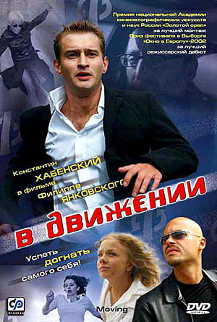
В движении
V dvizhenii
In Motion
Prodiuserskaia kompaniia ‘Slovo’, Art Pictures Group, Non Stop Productions, with the support of the Sluzhba kinematografii Ministerstva kul´tury Rossiiskoi Federatsii, 2002
Producers Fedor Bondarchuk, Viktor Glukhov, Sergei Mel´kumov, Stepan Mikhalkov, Elena Iatsura
Executive producer Oleg Demidov
Screenplay Gennadii Ostrovskii
Photography Sergei Machil´skii
Design Ekaterina Zaletaeva
Music Danila Kalashnik
Aleksandr Gur´ev Konstantin Khabenskii
Liza Kolesova Elena Perova
Vera Oksana Fandera
Vovan Mikhail Efremov
Liuda Aleksandra Skachkova
Lena Zorkina Ol´ga Sidorova
Ania Oksana Akin´shina
Ol´ga Somova Anastasiia fon Kalmanovich
Korean woman Ha Sun Ju
Aleksei Somov Aleksei Makarov
Guest Gosha Kutsenko
Man with briefcase Konstantin Murzenko
Sanek Pavel Melenchuk
Mitiagin Nikolai Chindiaikin
Gazizov Fedor Bondarchuk
Investigator Leonid Gromov
Bailiff Sergei Gusinskii
Representative of MegaBank Aleksandr Tiutriunov
Waiter Gennadii Ostrovskii
Pilot Ignat Akrachkov
Magazine editor Vladimir Sterzhakov
Archive worker Marina Golub
Singer Dmitrii Makarov
93 minutes

Call number DVD-193: In Russian
Region code All
Aspect ratio
Languages No subtitles
Features
Source cdvdvd.com

AND

Call number DVD 220: In Russian with optional English subtitles
Region code 1 and 5
Aspect ratio 16:9
Languages Optional English subtitles
Features Biographies and filmographies for the director, Filipp Iankovskii, and the actors Konstantin Khabenskii, Elena Perova and Oksana Fandera
Source SR Digital

Suggested reading

Prokhorov, A. ‘In Motion (v dvizhenii), 2003’, at Kinokultura, October 2003, http://www.kinokultura.com/reviews/R103moving.html (In English)

Some responses by Russian critics will be supplied in translation after the class

Essay questions:

‘The narrative structure of the film is determined by Gur´ev’s exhausted, breathless escape from his prescribed social roles in search of something authentic.’ (Aleksandr Prokhorov). What is the result of Gur´ev’s search in Filipp Iankovskii’s film V dvizhenii (In Motion), and what attitude does the director take towards him? (Russian Cinema: History, Politics, Society, 2005)

Filipp Iankovskii’s film V dvizhenii (In Motion) has been praised as one of the first Russian films to see through the surface glamour of contemporary Moscow life. Consider Iankovskii’s depiction of his journalist hero and his milieu in the light of this assessment. (Russian Cinema – History, Politics Society, 2007)

